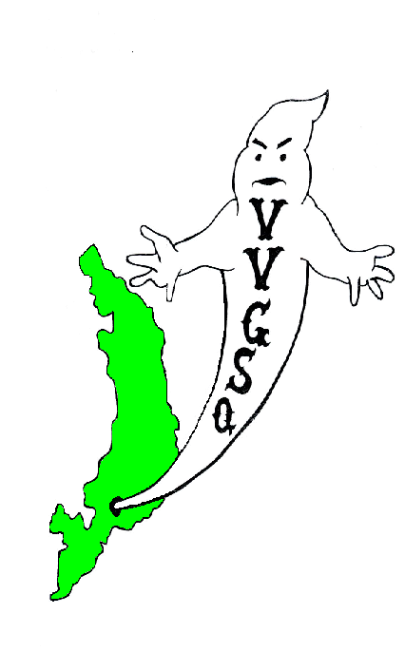
Vietnam Veterans Group of San Quentin

May 2012 General Meeting
Held in the Library on May 22, 2012.

EXECUTIVE COMMITTEE:

Chairman | Ron Self
Vice-Chairman | Barry Spillman
Secretary/Treasurer | Dave Basile
Outside Coordinator | Ron Self (Acting)
North Block Member-at-Large | Malcolm Jones
H-Unit Member at Large | Anthony Parker
West Block Member at Large | Harry Barton

Vice-Chairman Spillman called the meeting to order at 0942 hrs. Roll was called: 39 members present, 3 absent and 4-excused absence - there was a quorum. Our sponsor, Lt. R. Luna, was present. Thank you for joining us.

All present were asked to remove their hats for a moment of silence for those Missing-in-Action, those Killed-in-Action, and all other service members deployed in Iraq, Afghanistan, and around the world.

All members were asked if they received the April 2012 General Meeting minutes. All members did receive their minutes; no errors noted. A motion to accept the minutes requested by Mr. Barton, seconded by Mr. Johnson, and the motion passed.

SECRETARY/TREASURER'S REPORT:
Mr. Dave Basile: We had $2.788.00 returned to us from Sacramento. Our expenses included $314.50 in fund raiser refunds and $190.00 for 15 hats. We should have in our account about $4,860.00. I will not be able to confirm this until I receive a printout from Trust.

OUTSIDE COORDINATOR’S REPORT:
Mr. Self: The following correspondence received since our last meeting:

United Veterans of America Freeport, Florida
Chaplain Phillip Carter, NIV Savoy, Texas
Bill Anderson Seattle, Wash.
Herb Sallie Jr. Menlo Park, Ca.
Chaplin Caleb, USA, Vietnam Veteran North Carolina
David Cruzan Delano, Ca.

COMMITTEE REPORTS:

BY-LAWS:
Chairman Bob Kaser: Nothing new to report.

SCHOLARSHIP:
Chairman J. Robinson: The menu is complete and Mr. Mearse is ordering the food. The set-up and clean-up crew is as follows: Arnold, Kess, Parker, Barton, Goodlow, Farris, Baer, Tarvan, Steward, Cooper, Warren and Coleman. Specific duties are to be handed out in the near future. In addition, the winner of the Scholarship award is announced on Friday the 25th.

VIP OFFICE:
The next scheduled workshop is TBD.

COLOR GUARD:
Chairman Trent Capell: Speaking for Mr. Capell was Mr. Robinson. Just a reminder: the Color Guard will present Colors for the following events: Tentatively, Real Choices graduation May 25, 2012. On May 28 at 1200 hours on the lower yard to pay our respects for Memorial Day, then, that evening for the Alliance Banquet. Finally, during the Opening Day for the San Quentin Giants baseball season on June 2, 2012. You men will be busy; represent well.

HISTORIAN/WEBSITE:
Nothing to report.

STAMPS FOR SOLDIERS:
Mr. Rooke stated that stamp and tab collections are coming along fine.

FOOD SALE:
Food Sale committee is presently standing down. The Executive Committee wishes to thank all members who participated on a job well done. In spite of the obstacles, the men managed to fill and complete our death row commitment and general population commitment in three hours. I’m sure that is record time for this joint. Good job men.

PRESENTATION BOXES:
Chairman Schuhmacher: Speaking for Chairman Schuhmacher was Mr. Gomez who stated that 15 boxes are currently in the making. In addition Mr. Gomez had this to say, “As I am one of the sole participants in the assembly process, I am requesting additional VVGSQ members in PIA to lend a hand.” Mr. Warren stated to bring any sanding to him. Thanks, John. Completion will be on time. Machine Shop get ready.

OLD BUSINESS:

Vietnam Memorial Wall: Lt. Luna stated that he was in contact with the production people. Lt. Luna will remain in contact and attempt to work out a deal that favors consideration to the Memorial Fund, based in Washington DC. Mr. Gary Botha has returned from his Leave of Absence. He was asked to leave the room and in accordance with our By-laws, the General Body had to vote in order to bring him back into the group. Mr. Botha was unanimously accepted back into the V.V.G.S.Q. In addition, with the presentation of Colors on Memorial Day, Mr. Craig Johnson suggested that the entire VVGSQ be arranged in Company formation to pay tribute in honoring the fallen. Mr. Basile stated that on Monday May 28th all of the VVGSQ should fall out on the lower yard in front of R&R at 1100 hours. At that time we can form up in ranks, pay tribute to the fallen, than have Lt. Sam Robinson take a group photo that will be included in this years Banquet program. In addition, Mr. Johnson suggested that posters be made and placed in the housing units inviting all veterans a place on the yard with us on Monday. So let it be written, so let it be done.

NEW BUSINESS:

Secretary Basile introduced the following new members: Veteran Gaskins, US Army, and Veteran Johnston, US Army. Both soldiers introduced themselves and were welcomed by the General Membership. Mr. Coleman, Mr. Soltero, and Mr. Woods were asked to leave the room as the membership elected to vote in all three to the V.V.G.S.Q. Congratulations. Secretary Basile notified the membership that nominations for the Executive Committee would take place in the June 24 meeting. That concluded New Business.

Vice-Chairman Spillman thanked Lt. Luna for attending on behalf of the entire group.

A motion to adjourn the meeting by Mr. Gomez and seconded by Mr. Stauffer. A vote was taken and the motion passed. The meeting adjourned at 1031 hrs.

UPCOMING EVENTS

June 17, 2012 | Scholarship Banquet, Protestant Chapel, San Quentin
June 24, 2012 | General Meeting in the Library @ 0900 hrs
July 29, 2012 | General Meeting in the Library @ 0900 hrs

Submitted,

__________________________ __________________
D. Basile, DATE
V.V.G.S.Q. Secretary / Treasurer

__________________________ __________________
R. G. Self DATE
V.V.G.S.Q. Chairman

NOTED

__________________________ __________________
R. Luna DATE
Correctional Lieutenant
V.V.G.S.Q. Co-Sponsor

Vietnam Veterans Group of San Quentin  Attn: Lt. K. Evans, Chief sponsor  San Quentin State Prison  1 Main Street  San Quentin, CA 94964-0001  Website: http://vvgsq.tripod.com/ | Chief Sponsor: Lt. K. Evans, (415) 454-1460 x 5205  Co-Sponsor: Lt. R. Luna, (415) 454-1460 x 5808

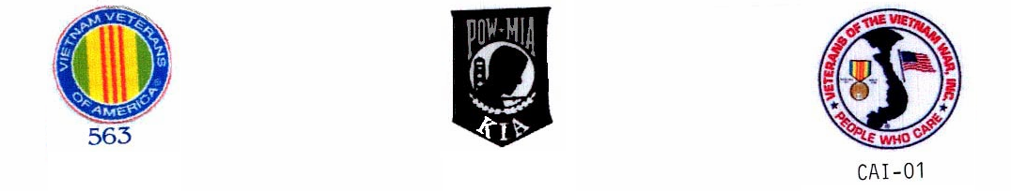
CURRENT ROSTER as of 5/22/12

 |  | NAME | CDC # | HOUSE | ETH. | CUST. | STATUS | COMMENTS
1 | √ | ADAMS DWIGHT | K-98701 | 1N073L | BLK | CLOB | Voting Mbr
2 | √ | ARNOLD, RICHARD | P-27171 | 2N069U | WHI | CLOB | Voting Mbr | VIG
3 | A | BAER, STAN | K-06285 | 3N039U | WHI | MEDA | Voting Mbr | VIG,
4 | √ | BARTON, HARRY | C-03120 | 2W068L | WHI | MEDA | Voting Mbr | VIG,W-Blk Mbr @ Large,
5 | √ | BASILE, DAVID | C-70016 | 1N038U | WHI | MEDA | Voting Mbr | VIG, Secretary/Treasurer
6 | √ | BEAVERS, LAWSON | P-14974 | 1N015L | BLA | CLOB | Voting Mbr | VIG, Color Guard
7 | √ | BOTHA, GARY | D-88086 | 1W061L | WHI | MEDA | Voting Mbr
8 | A | BROWN, DAVID | AE-3137 | 3W003L | BLA | MEDB | Voting Mbr
9 | √ | BUTLER, DUANE S. | D-91464 | 2N017L | BLA | MEDA | Voting Mbr | VIG
10 | √ | CAFFALE, GEO | D-97941 | 3N098L | WHI | MEDA | Voting Mbr | VIG
11 | E | CAPELL, TRENTON | E-91949 | 3N011U | BLA | CLOB | Voting Mbr | Chairman Color Guard
12 | √ | COLEMAN, RONALD | C-87435 | 2W010L | BLA | MEDA | Voting Mbr
13 | √ | COOPER, GARY | T-15604 | 3W013L | WHI | CLOB | Voting Mbr
14 | √ | FAISON, POPEYE | C-68462 | 2N028U | BLA | MEDA | Voting Mbr
15 | A | FARRIS, DARRYL | T-33812 | 5N071U | BLK | CLOB | Voting Mbr
16 | √ | GASKINS, SAMUEL | C-27569 | 3W079L | BLK | MEDA | PROBATION | Probationary until 8/26/12
17 | √ | GOMEZ, JOHNNY | K-72622 | 4N042L | MEX | CLOB | Voting Mbr
18 | √ | GOODLOW, KENNETH | C-75705 | 3W102L | BLA | CLOB | Voting Mbr
19 | √ | GUMPAL, MAURO | P-00591 | 4N036L | OTH | CLOB | Voting Mbr
20 | √ | HARRIS, SAMUEL | C91589 | 2W093L | BLK | MEDA | PROBATION | Probationary until 8/26/12
21 | √ | HERNANDEZ, JESSE | K-21116 | 2W036L | WHI | MEDA | Voting Mbr
22 | √ | HYLTON, ROBERT | AI4554 | 4H077L | WHI | MEDA | PROBATION | Probationary until 6/24/12
23 | √ | JOHNSON, CRAIG | C-08327 | 4W063L | WHI | MEDA | Voting Mbr
24 | √ | JOHNSTON, JOHN | F01795 | 4H041L | WHI | MEDA | PROBATION | Probationary until 8/26/12
25 | √ | JONES, MALCOLM | J-04780 | 4N008L | BLA | CLOB | Voting Mbr | VIG, NB Member at Large
26 | √ | KASER, BOB | D-41415 | 2N025L | WHI | MEDA | Voting Mbr | VIG, Chairman Bylaws
27 | √ | KESS, PHILLIP | G-62396 | 5H057L | BLA | MEDB | Voting Mbr
28 | √ | MARTIN, J.D. | D-44170 | 4W075L | BLA | MEDA | Voting Mbr
29 | √ | PARKER, ANTHONY | D-20753 | 5H006L | BLA | MEDB | Voting Mbr | H-Unit Member at Large
30 | √ | POLLEY, AHMAD | C-57727 | 2W084L | BLA | MEDA | Voting Mbr | VIG, Color Guard
31 | √ | ROBINSON, GARVIN | K-52086 | 3N012L | BLA | CLOB | Voting Mbr | Scholarship Chairman, Color Grd
32 | √ | ROOKE, PETE | C-76159 | 1N020L | WHI | CLOB | Voting Mbr | Tabs/Stamps for Soldiers
33 | √ | SANDERS, GREG | E-05222 | 4W017L | WHI | MEDA | Voting Mbr | VIG, Outside Coordinator
34 | A | SCHUHMACHER, CHRIS | T-31014 | 4N093L | WHI | MEDA | Voting Mbr | Presentation Box Chairman
35 | E | SELF, RONALD | K-21055 | 4N083L | AMI | CLOB | Voting Mbr | VIG, VIP, Chairman
36 | √ | SNIDER, JAMES | F-30077 | 2N100U | WHI | CLOB | Voting Mbr | Scholarship
37 | √ | SOLTERO, DANIEL | D-65858 | 1W074U | WHI | CLOB | Voting Mbr
38 | √ | SPILLMAN, GLEN | F-42695 | 3N035U | WHI | CLOB | Voting Mbr | VIG, Vice Chairman
39 | √ | STAUFFER, PAUL | T-80750 | 3N065U | WHI | CLOB | Voting Mbr
40 | √ | STEWART, NORFLEET | E-90026 | 4W079L | BLA | CLOB | Voting Mbr
41 | √ | STONER, JEFFREY | D03596 | 5W085U | WHI | MEDA | PROBATION | Probationary until 6/24/12
42 | √ | TARAN, DAVID | E-76518 | 2W038L | WHI | MEDA | Voting Mbr
43 | E | VICK, ERNIE | P-59262 | 2N016L | WHI | CLOB | Voting Mbr | VIG, Scholarship
44 | √ | WARREN, JOHN | T-86358 | 4H065L | MEX | MEDB | Voting Mbr
45 | √ | WOODS. JIMMIE | V-68113 | 3H022L | BLA | MEDB | Voting Mbr

√ = Present
E = Excused Absence
A = Unexcused Absence

